Group Data-rocker

Problem set 3

Adrian Wüest - Matr.N° 13740428
Larissa Staubli – Matr. N° 13754874

1. Pencil and Paper

2. Empirical Application

1. Dealing with Measurement Error

a.
Yes, a corruption index relies on many reported data where it is very likely that some observations got lost. These non-systematic errors result in a measurement error.
Also, child mortality might suffer from measurement errors because of many child deaths don’t happen at the hospital and therefore it is very likely that not all of them were reported.

b.
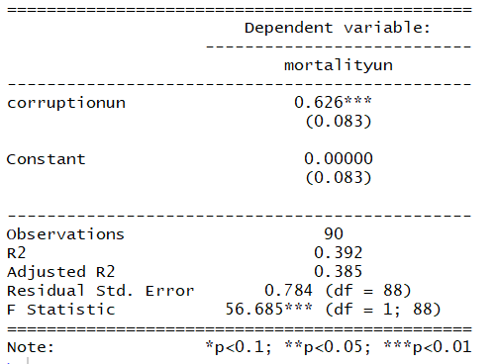
i The beta_hat is 0.626, positive and significantly on a 1% level. The p-value for the one-sided test H₀: ß>0 is 0.792. Therefore, we fail to reject the Null hypothesis that the beta is bigger than 0. We only can reject the hypothesis that ß is zero.
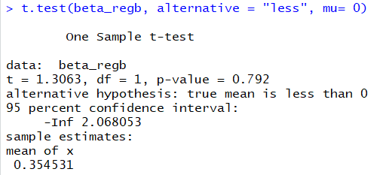

ii If the assumptions hold, an increase in the corruption index of the UN by one standard deviation increases on average the child mortality index of the UN by 0.626 standard deviations. In our opinion this is effect is rather small, because the change in corruption of 1 results in a comparable smaller change of 0.626 in child mortality.

iii This is the scatterplot of mortality index of the UN on the corruption index of the UN including the regression and the 95% confidence interval.
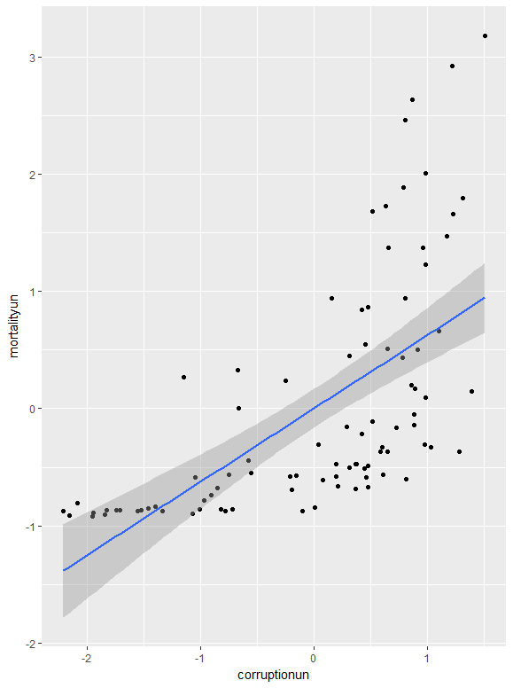

c.
i Yes we think that this model satisfy the conditions of classical measurement error, because in general the death of people has to be determined by an official organization. This rule is applied almost in all countries and only in a few cases some death of children get lost, which can be defined as measurement errors. It is not a deliberate misrepresentation of variables.
According to the assumption of classical measurement error we would expect that the marginal effect of corruption on hospital_deaths has to be very similar to the marginal effect of corruption on mortality.

ii
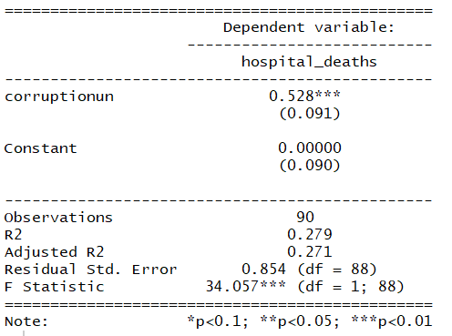
The coefficient of the regression of hospital_deaths on corruption is 0.528, significant on the 1% level and slightly lower than in b. This was also expected because people who have to go to the hospital might be already worse independent of the corruption. But in general, we can say that the marginal effect is almost the same than in b, which supports the assumption in c.i) that the variables satisfy the classical measurement error.

iii
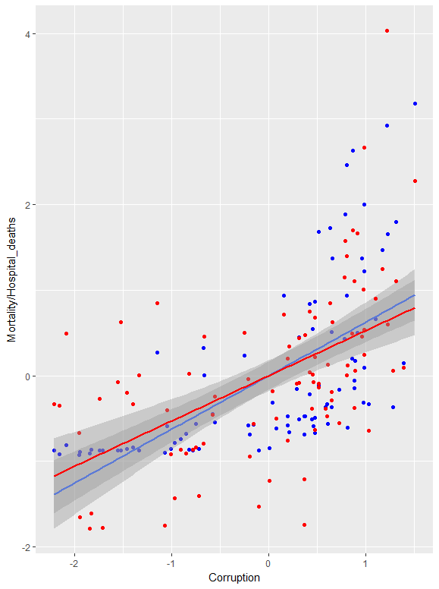
The blue line/points correspond to the Mortality on corruption regression and the red line/points on the hospitality deaths on corruption regression. As you can see, the two regression functions are very similar, and the confidence intervals overlap. This overlap of the confidence intervals strengthens our opinion that these two models aren’t able to be distinguished from each other.

d.
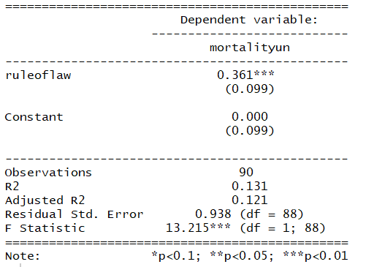
The coefficient is 0.361, significant on the 1% level and quite smaller than the coefficient with based on the correlation index (0.626). Actually, we expected a quite similar coefficient for the regressor rule of law, because it is also an index for corruption and highly correlated with UN corruption index. But the value is quite different, which indicates how results change for different corruption measurements.

e.
i The difference in the setting between the measurement errors from the pencil paper question and by the government collected data is, that the errors might be systematically and therefore not be randomly. This results in a correlation between the error term and the X’s. So, the beta will be biased! Consequently, the variable is not likely to satisfy the conditions of classical measurement error, because under this assumption the variable wouldn’t be biased.

ii The bias will probably be negative because states with high corruption are also more willing to (and it’s more possible) influence the study. Therefore, these countries might reduce their child mortality on purpose.

iii
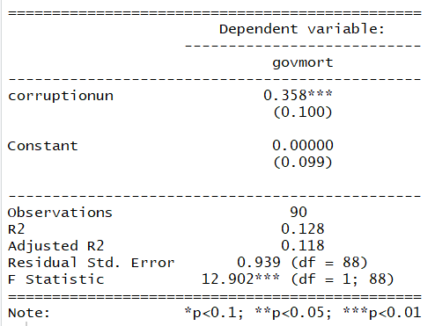
The coefficient is 0.358, significant on the 1% level and quite smaller than the coefficient in 1b). This was also expected because high corruptive nations might more influence such studies.

f.
We think that the estimated effect in 1e is probably the worst because it relies on the government behaviour. A systematically influence of governments with high corruption seems very likely and therefore the coefficient is biased.

IV Regression

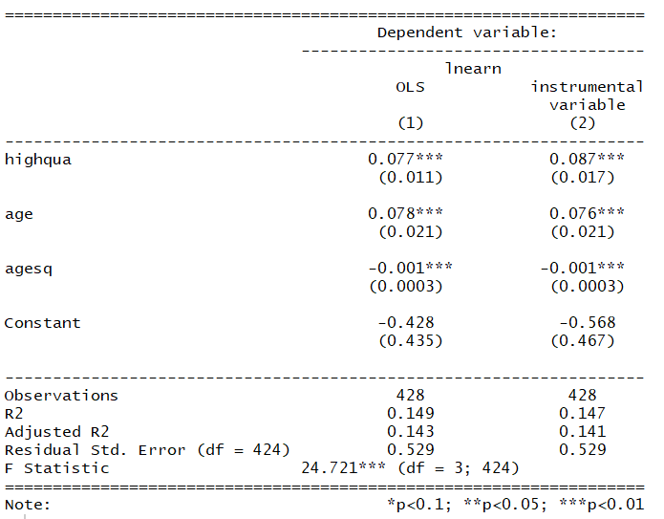
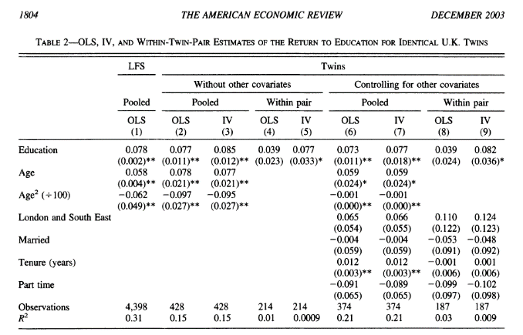
a.

i No the results are quite similar.

ii No. The coefficient on the constant is not interpretable. It is just to make sure that the OLS sum of least squares has not to go through the origin.

iii If the coefficient is consistent, for each more year of school for a twin his average income increases by 8.7%.

b.

i First, education optimally depends on the twins’ ability and ability on average very likely is positive correlated with wage. Therefore, this regression suffers from OVB!
Second, whether a person joins school for a long time also might depend on its parental background. So, if the parents also joined university their children more likely do too.

ii Ability influences the year of schools positively. Consequently, ability would lead to positive bias.
Parental backgrounds as we see it (education level of parents, financial background, support) influences years of schools positively, therefore it leads also to a positive bias.
Siblings behaviour, if my brother goes for University I do so too.

iii For ability: We think that ability is a result of individual experience and has no relation either within twins and therefore can’t not control for ability by inserting twihigh as an IV.

For parantial background: As we assumed in ii) parantial backgroung has a positive influence in years of schooling. This is true for both twins and therefore we can use twihigh as an IV to control for parantial background.

iv Comparing OLS with IV you can see, that the effect of highqua has in IV a higher impact on earnings. This is very surprising because we originally though that the coefficient of highqua was positively biased and therefore by controlling by an IV the resulting coefficient should decrease. But our estimated effect went in the opposite direction. Is the instrument right? Has parantial background a negative effect?

v It is a strong instrument, because twihigh has a very jointly significant impact on (the 1% level) highqua.
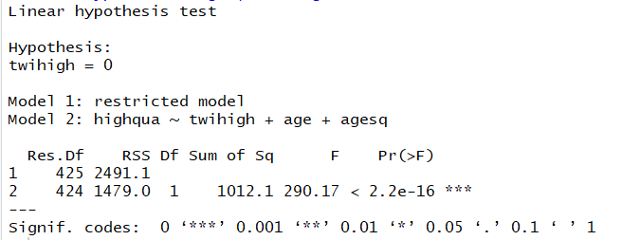

vi We don’t believe the results, because we think the instrument twihigh is not an accurate instrument. We don’t see the exogeneity of this variable. This results in a too high effect of highqua on earnings and therefore the coefficient is still biased.

